Congo Basin Panda Impact Adoption Readiness
  - Data Analysis Report
Prepared for: Regional Strategic Management
Date: 2026-03-10
Prepared by: Thaddee Ghislain ESSOMBA NKOULOU

Table of Contents
Table of Contents 2
List of Figures 3
List of Tables 3
1. Executive Decision Brief 4
2. Current State Assessment (Skills, Systems, Connectivity) 4
3. Capability Gaps and Intervention Priorities 6
4. Training Needs Analysis 8
5. Implementation Roadmap and Milestone Gates 9
Three-Month Action Plan for CMR and Gabon 10
6. Budget Requirements and Investment Strategy 12
Category-Organized Budget by Country and Budget Item 13
7. Risk Register and Mitigation Summary 14
8. Priority Recommendations 14
Annex A. Data Collection Tool 15
Annex B. Dataset 15
Annex C. Methodology 15

List of Figures
- Figure 1. Aggregate PI readiness scores by country office.
- Figure 2. Dedicated PMEL staff per 10 active projects, with staff and project counts shown on each bar.
- Figure 3. Role-based competency heatmap for Panda Impact tasks.
- Figure 4. Methodological maturity and content readiness by country.
- Figure 5A. Training priority by country and module, where rank 1 is the highest need
- Figure 5B. Preferred training modality by country, showing the split between on-site and online delivery
- Figure 6. Strategic implementation roadmap and dependency context.
- Figure 7. Total required investment by intervention category.

List of Tables
- Table 1. PMEL staffing profile by office, combining staffing depth, focal-point protection, and project portfolio load.
- Table 2. Three-month action plan for role-based Panda Impact adoption in CMR and Gabon.
- Table 3. Category-organized enabling-cost budget with subtotals and overall total.

1. Executive Decision Brief
The Congo Basin region is at a critical juncture in its digital transformation. The transition to the Panda Impact (PI) platform is currently assessed at a 55.68% regional readiness average. Technical analysis indicates that while software systems are available, the underlying human resource capacity and capability still require significant strengthening to ensure operational viability.
To address the identified gaps, the region now requires a strategic investment of USD 1,950,359.50. This budget is primarily focused on human capital, with USD 1,784,120.00, or 91.5% of the total, allocated to staffing. This reflects the 4-year staffing structure requested by country offices, supported by a regional PMEL management function.
A critical metric for readiness remains the ratio of dedicated PMEL staff per 10 active projects (Figure 2). The regional average is only 0.64 dedicated staff per 10 active projects, equivalent to 6 staff supporting 94 projects. Offices such as the Central African Republic (CAR) and the Republic of Congo (RoC) continue to operate with no dedicated PMEL staff, while the Democratic Republic of Congo (DRC) shows the strongest ratio at 1.5 staff per 10 projects but still lacks full focal point protection. This presents a continuing risk to data integrity and Roadmap 2030 reporting.
The proposed strategy continues to involve a sequenced rollout linked to specific Milestone Gates. This ensures that resources are released only upon verification of foundational readiness criteria in each office.

2. Current State Assessment (Skills, Systems, Connectivity)
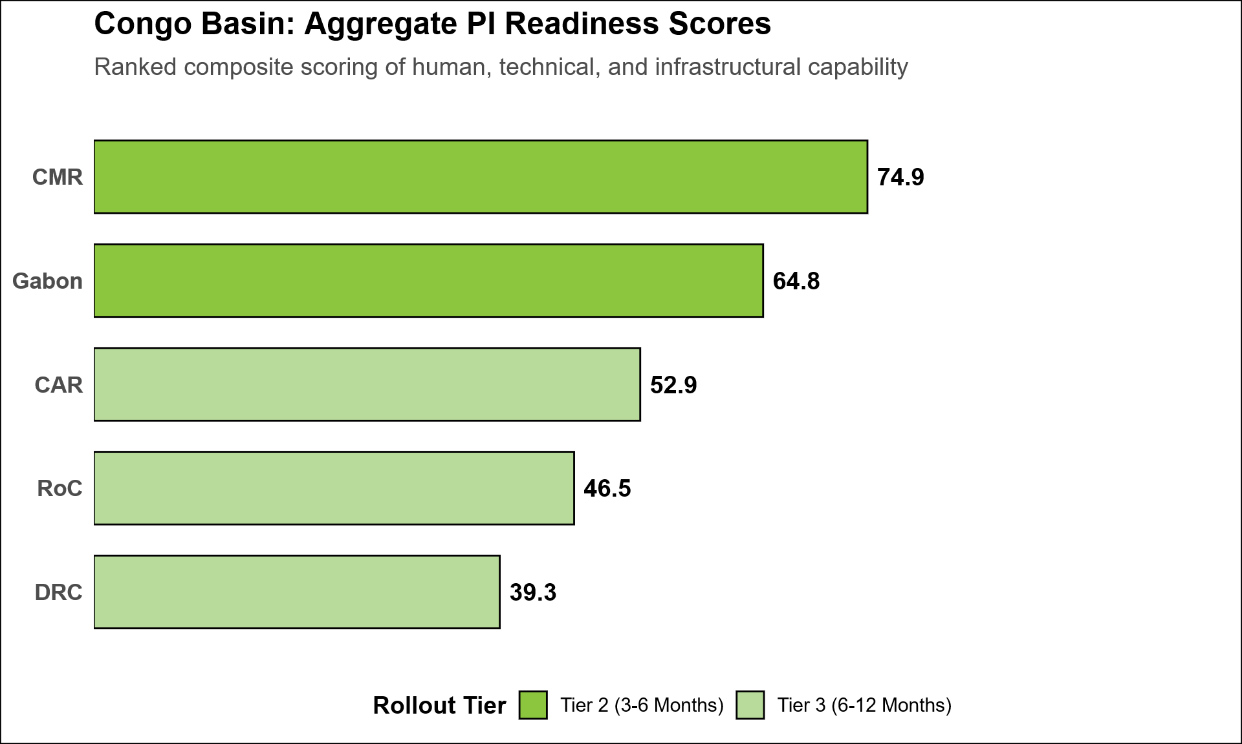
Figure 1. Aggregate PI readiness scores by country office.
The data in Figure 1 illustrates a significant disparity in readiness across the region. Cameroon (CMR) shows the highest maturity at 74.9, placing it at the threshold of "Tier 1" readiness. This position is largely due to established experience with digital tools such as SMART and Kobo. Conversely, the DRC maintains the lowest score at 39.3.
Given that the DRC manages the region's largest portfolio ($37M), the current lack of infrastructure support represents a high-priority risk that requires mitigation to prevent a regional reporting vacuum.
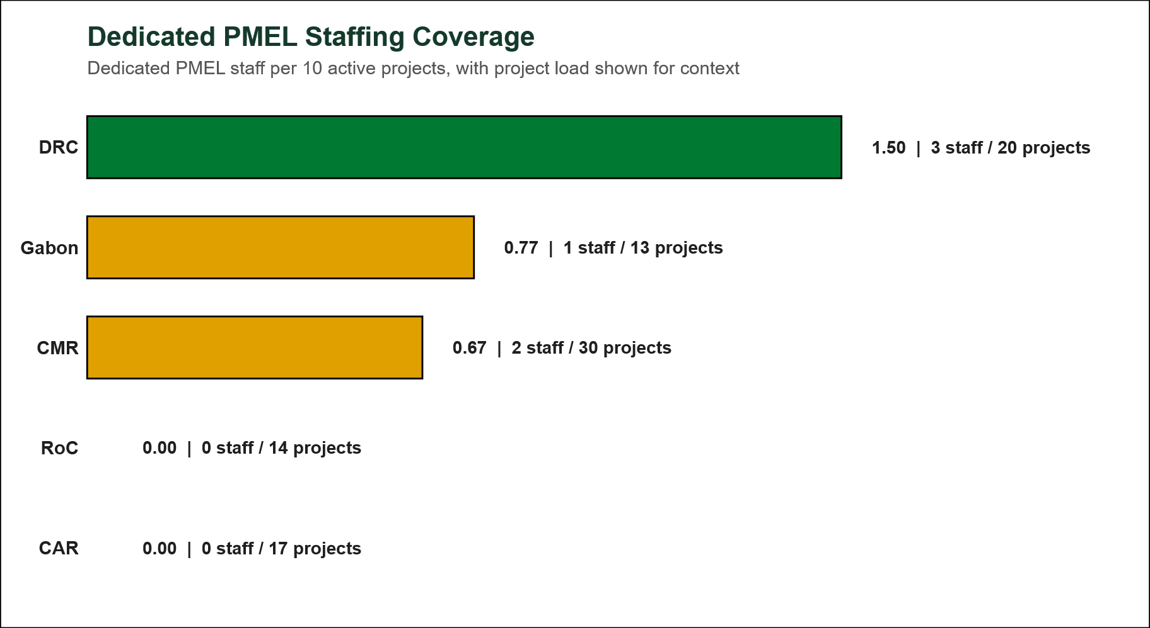
Figure 2. Dedicated PMEL staff per 10 active projects, with staff and project counts shown on each bar.
Data suggests that PMEL responsibilities in the DRC are currently included within other roles. Operational standards for Panda Impact adoption necessitate dedicated roles that require specialized focus that cannot be maintained as a secondary task.
The regional PMEL staffing architecture reveals a stark disparity between project volume and dedicated monitoring capacity. While Cameroon (CMR) and Gabon have secured high technical integrity through 100% dedicated focal points, they face a high "burden of scale" as shown in figure 2.
The lack of a 100% dedicated focal point means these resources are often diverted, diluting the quality of planning, monitoring, evaluation and learning in COs. The most acute risk remains in CAR and RoC; these offices lack any dedicated PMEL roles, relying on part-time focal points with only 15%- and 5%-time allocation respectively to manage portfolios of 17 and 14 projects.
The above configuration creates a "monitoring vacuum" in which the adoption of Panda Impact is nearly impossible without recruiting dedicated PMEL teams to manage the project portfolio load.
Table 1. PMEL staffing profile by office, combining staffing depth, focal-point protection, and project portfolio load.
Country | Dedicated Staff | 100% Dedicated? | Focal Point Time | Active Projects | Staff per 10 Projects
DRC | 3 | No | 0% | 20 | 1.50
CMR | 2 | Yes | 100% | 30 | 0.67
CAR | 0 | No | 15% | 17 | 0.00
Gabon | 1 | Yes | 100% | 13 | 0.77
RoC | 0 | No | 5% | 14 | 0.00

3. Capability Gaps and Intervention Priorities
The regional competency heatmap identifies specific functional areas where execution is currently constrained.
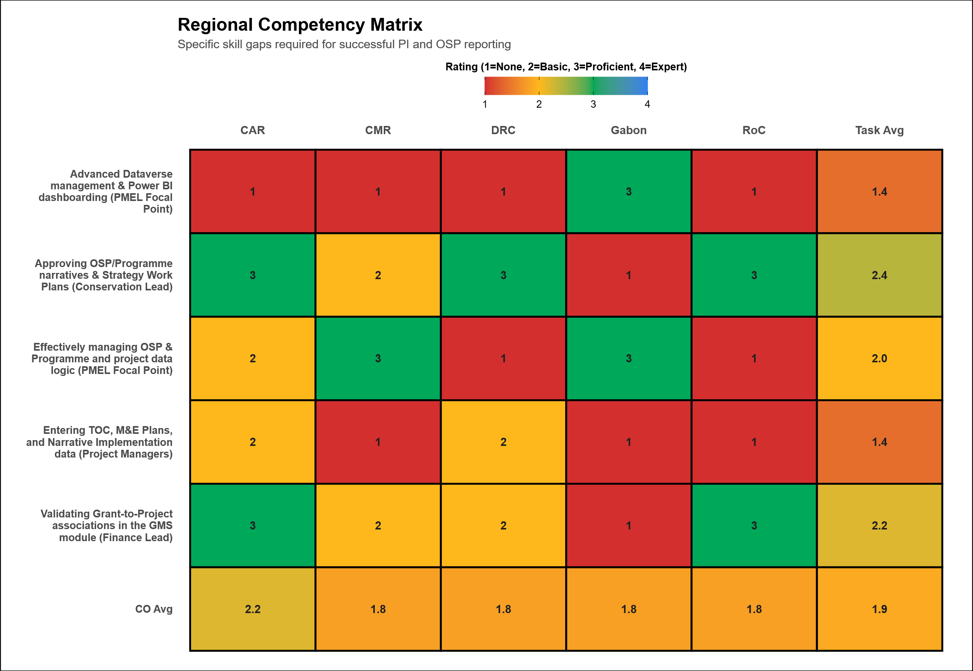
Figure 3. Role-based competency heatmap for Panda Impact tasks.
The heatmap identifies two main regional bottlenecks: Advanced Dataverse management and Power BI dashboarding, and Narrative and Theory of Change entry in Panda Impact, both averaging 1.4/4. These gaps are not confined to one country. Advanced Dataverse capacity is weak in CAR, CMR, DRC, and RoC, while Narrative and ToC entry is also consistently low across offices. This suggests that interventions should move beyond general IT training toward targeted, role-based support for PMEL focal points and Project Managers on Dataverse use, ToC and M&E plan entry, and core OSP and project data-management tasks.
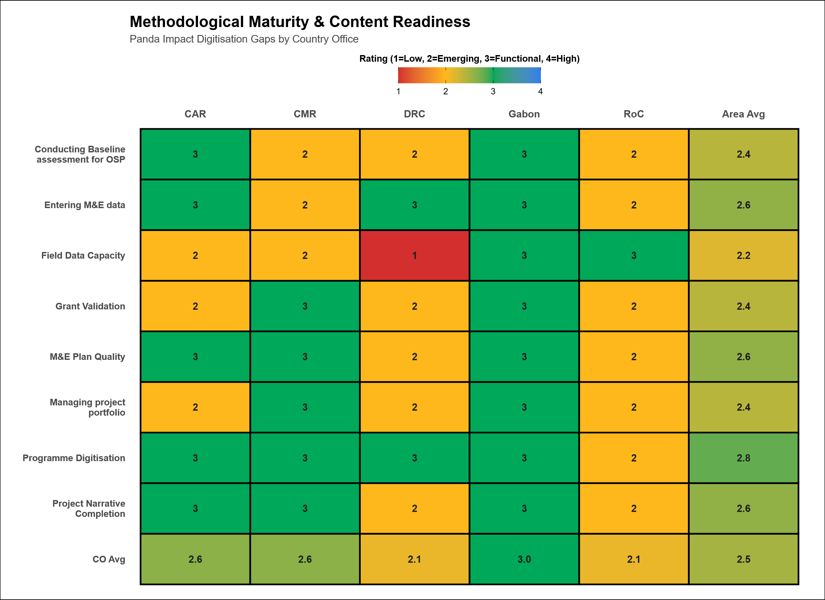
Figure 4. Methodological maturity and content readiness by country.
The analysis shows that the areas needing the strongest improvement are Field Data Capacity, conducting baseline assessments for OSP, managing project portfolios, and grant validation. The weakest overall capability profiles are in DRC and RoC, while CAR and CMR are intermediate and Gabon remains the strongest. Most of the lowest-scoring areas require technical PMEL capacity, reinforcing the need for stronger PMEL support in country offices.
Given the current digitization status across COs, immediate support is especially needed for field data systems and OSP baseline establishment.

4. Training Needs Analysis
This matrix ranks country-specific training requirements based on CO feedback.
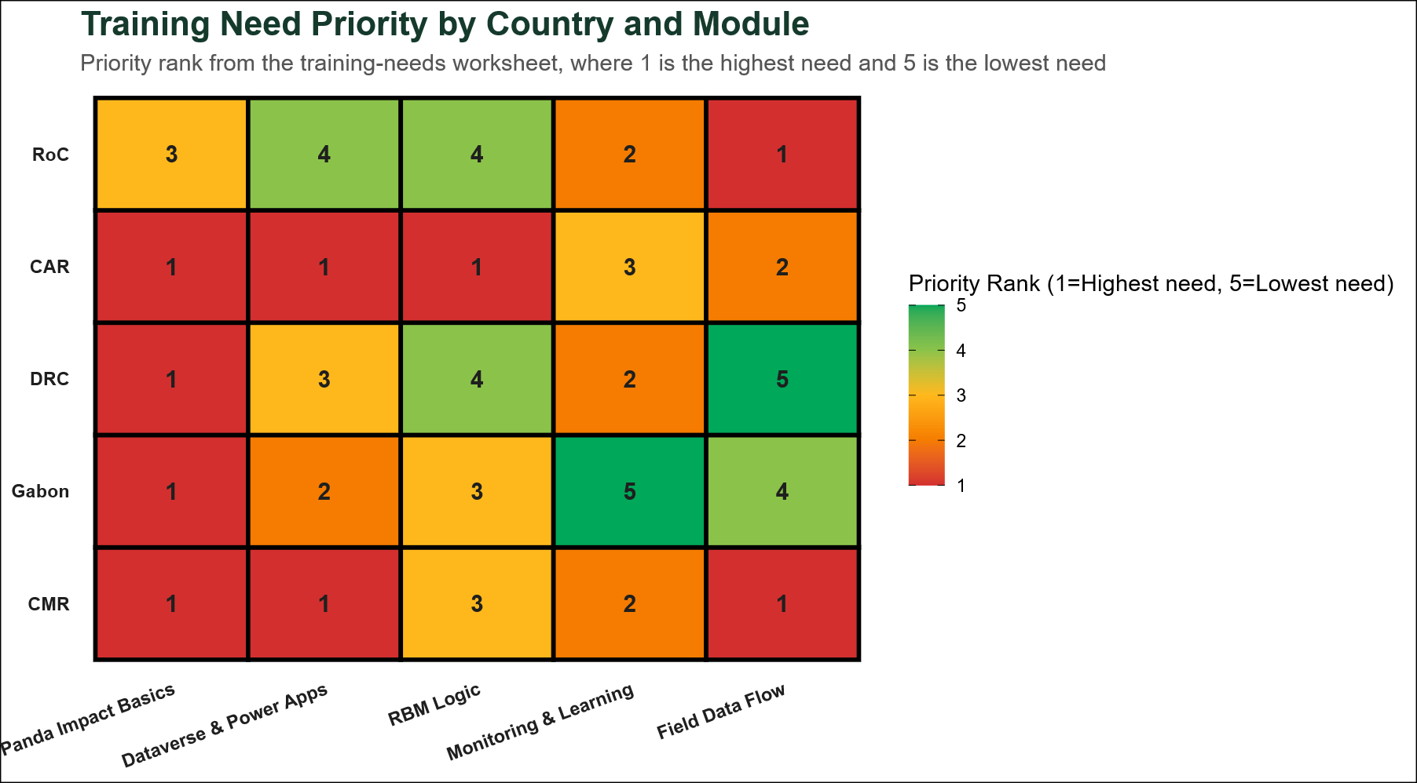
Figure 5A. Training priority by country and module, where rank 1 is the highest need.
The capacity-building framework for the Congo Basin should be anchored in the training needs that are both most urgent and most widely shared across country offices. The Training Priority Analysis (Figure 5A) shows that the strongest regional demand is for Panda Impact Basics and Dataverse and Power Apps, indicating that the immediate capacity gap is less about advanced methodology in isolation and more about consistent operational use of the platform and its core data tools. Field Data Flow also emerges as a significant priority in selected offices, while RBM Logic and Monitoring and Learning appear as more targeted needs that should be addressed selectively rather than as the first regional training wave.
To address these needs effectively, a mix of online and in-country training is needed. There is an overwhelming demand for on-site technical clinics across all the countries except DRC. Consequently, the roadmap will prioritize "Methodological Sprints" —on-site intensives that combine logic training with the physical setup of data collection tools.
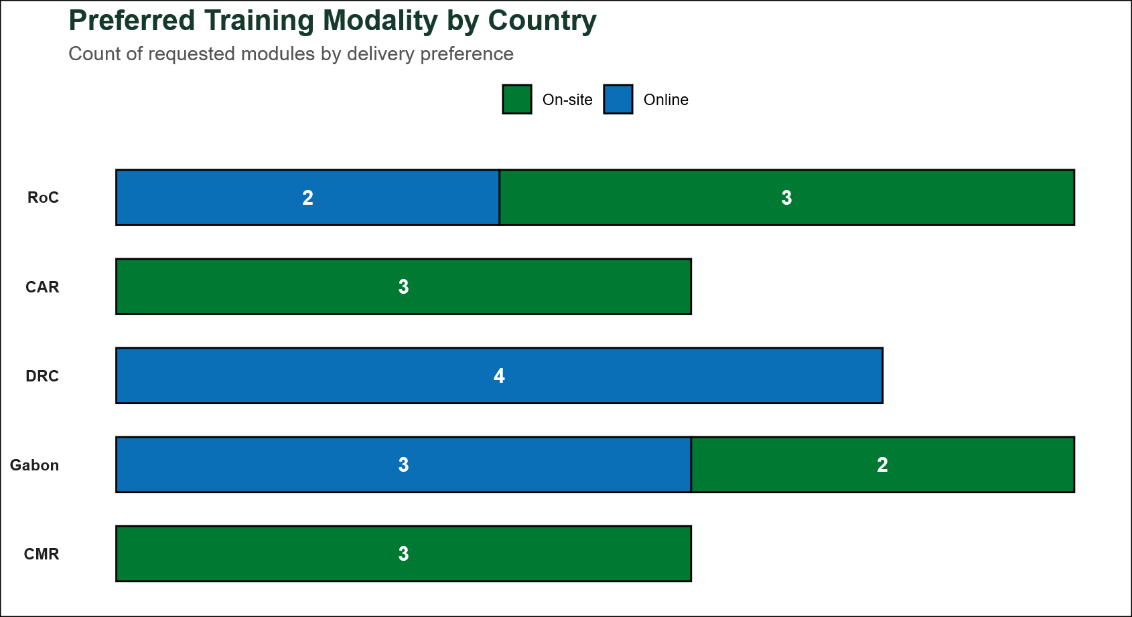
Figure 5B. Preferred training modality by country, showing the split between on-site and online delivery.

5. Implementation Roadmap and Milestone Gates
The roadmap is sequenced to maximize regional efficiency. Higher-readiness offices (Tier 2) are prioritized for accelerated digitization, while Tier 3 offices receive intensified support over a longer duration.
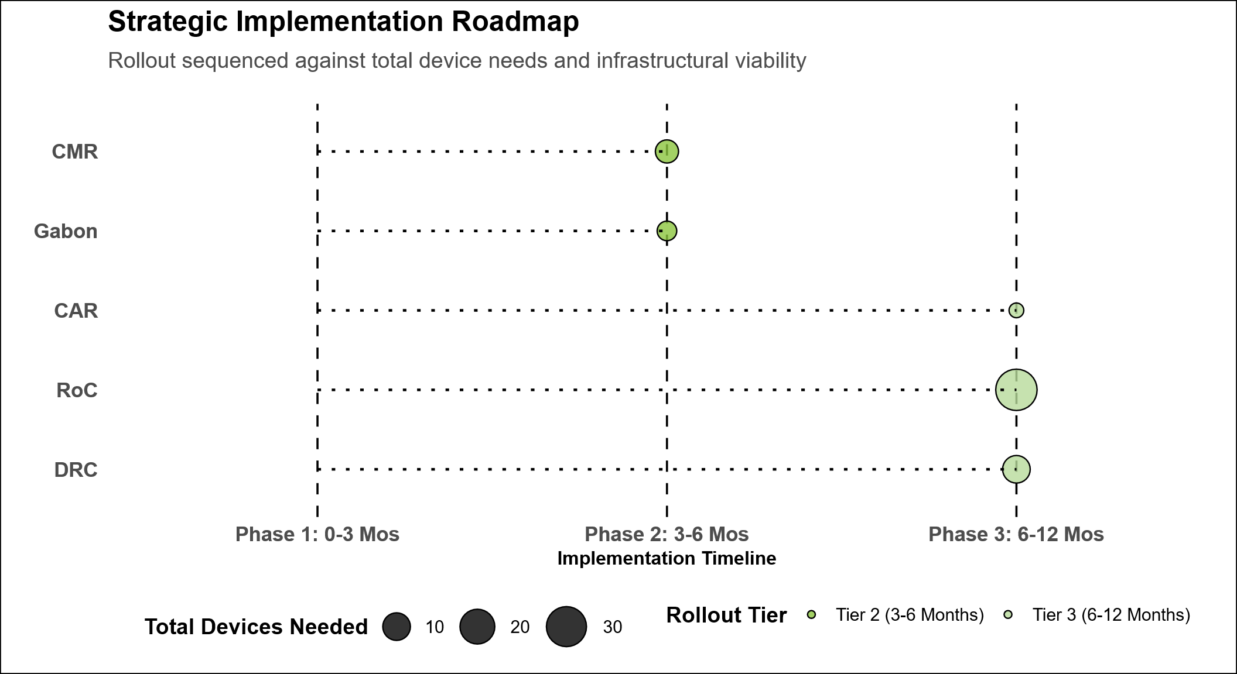
Figure 6. Strategic implementation roadmap and dependency context.
The implementation timeline is driven by the specific challenges identified in each office tier:
- Phase 1: Acceleration (0-3 Months): Focuses on Cameroon and Gabon (Tier 2). Because these offices face fewer structural hurdles, they are positioned to complete the digitization of their OSPs and project portfolios rapidly, serving as regional models.
- Phase 2: Transition (3-6 Months): Initiates intensified support for CAR and RoC (Tier 3). Actions include recruiting dedicated PMEL staff and initiating hardware/connectivity upgrades to facilitate stable platform usage.
- Phase 3: Deep Support (6-12 Months): Focuses on the DRC (Tier 3). Given the scale of the portfolio and the current staffing deficit, this phase allows for a longer, supervised digitization cycle once foundational gates (staffing and Starlink/hardware) are cleared.

Three-Month Action Plan for CMR and Gabon
Table 2. Three-month action plan for role-based Panda Impact adoption in CMR and Gabon.
Month | Country | People Targeted | Panda Impact Use Focus | Modality | Why this sequence | End-of-month milestone
Month 1 | CMR | MEL Staff, Conservation Director, Programmes & Projects Managers | Panda Impact Basics, dashboard navigation, project setup discipline, and Kobo-to-Dataverse field-data flow | On-site bootcamp | CMR has three rank-1 training needs and all request on-site delivery, making it the clearest candidate for a fast in-person start | Core users can navigate the platform, assign responsibilities, and run a first supervised project update cycle
Month 1 | Gabon | MEL Staff, Conservation Director, Programmes & Projects Managers | Panda Impact Basics, leadership dashboard use, and field-data management for site-to-office reporting | On-site launch clinic | Gabon's foundational needs include Basics and Field Data Flow as on-site requests, so the first month should establish shared operating habits in person | Office leadership and delivery teams can review dashboards together and complete a first end-to-end data capture and review exercise
Month 2 | CMR | MEL Staff and Programmes & Projects Managers, with Conservation Director in review session | Advanced Dataverse & Power Apps use, indicator updates, reporting routines, and data-quality checks | Hybrid coaching with on-site practice and remote follow-up | CMR's Dataverse demand is rank 1, so month 2 should convert the foundational bootcamp into routine data entry and monthly reporting behavior | CMR completes one full monthly reporting cycle in Panda Impact with reviewed data-quality corrections
Month 2 | Gabon | MEL Staff, Programmes & Projects Managers, Conservation Director | Dataverse & Power Apps, RBM Logic, Monitoring & Learning, and management use of review dashboards | Blended: online module sequence plus coaching clinic | Gabon's remaining demand is mainly online and spans system use, results logic, and monitoring, so a blended month avoids overloading field teams | Gabon updates results chains and indicators in the system and uses dashboard evidence in one management review meeting
Month 3 | CMR | MEL Staff, Conservation Director, Programmes & Projects Managers | Supervised live use for project management, routine monitoring updates, quarterly narrative reporting, and corrective-action tracking | On-site mentoring plus remote troubleshooting | By month 3 CMR should move from training into supervised business use because the office already has the strongest readiness profile | CMR demonstrates weekly system use, produces a management-ready report extract, and closes a short list of user errors
Month 3 | Gabon | MEL Staff, Conservation Director, Programmes & Projects Managers | Supervised live use for programme oversight, indicator review, lesson logging, and reporting quality assurance | Blended mentoring | Gabon needs one month of coached application after its wider module package to embed use across technical and leadership roles | Gabon completes a coached operating cycle and adopts a standing monthly dashboard-and-report review routine

6. Budget Requirements and Investment Strategy
CO requires an investment of USD 1,950,359.50, which is structured to prioritize human capital over pure hardware procurement for CO.
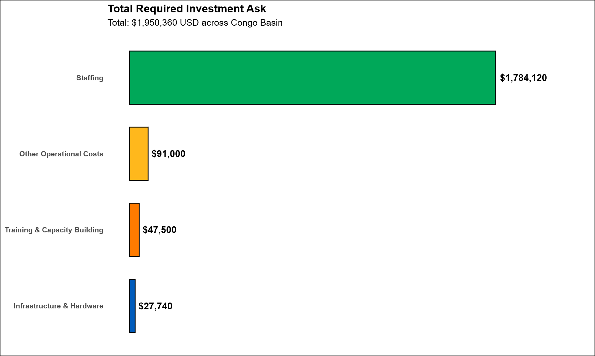
Figure 7. Total required investment by intervention category.
The allocation of USD 1,784,120 to Staffing, representing 91.5% of the total investment, reflects the central role of PMEL capacity in enabling sustained Panda Impact adoption across the Congo Basin. This staffing requirement is designed to address the region’s most binding constraint: insufficient dedicated technical capacity to manage data quality, reporting discipline, system use, and country-level implementation support. The proposed investment therefore prioritizes a 4-year staffing structure across country offices, reinforced by a regional PMEL management function, as the core enabler of operational readiness and long-term platform performance. Comparative data shows that successful digitization in CMR and Gabon is linked to staff dedication, while the lack of progress in the DRC is linked to its absence.
Furthermore, the allocation of USD 27,740 for hardware (laptops/tablets) is a technical prerequisite for offices like Salonga, where current hardware does not meet the minimum requirements for Power Apps and Dataverse synchronization.

Category-Organized Budget by Country and Budget Item
Table 3. Category-organized enabling-cost budget with subtotals and overall total.
Category / Country | Budget Item | Qty | Period | 4 year cost Amount (USD)
Staffing
Regional | Congo Basin Regional PMEL Manager | 1 | 4 year cost | 300,000
CAR | PMEL Officer | 1 | 4-year cost | 120,000
CMR | PMEL Officer | 1 | 4-year cost | 120,000
CMR | PMEL Landscape Assistant | 4 | 4-year cost | 160,000
DRC | Senior Officer – PMEL | 1 | 4-year cost | 360,000
DRC | Data Manager | 1 | 4-year cost | 240,000
Gabon | PMEL Assistant | 1 | 4-year cost | 139,320
RoC | Senior Officer – PMEL | 1 | 4-year cost | 204,000
Roc | Officer - PMEL | 1 | 4-year cost | 140,800
Subtotal: Staffing |  |  |  | 1,784,120
Training & Capacity Building
Regional | Congo Basin Regional PMEL Manager travel | 4 | 4-year cost | 20,000
CMR | Panda Impact & PMEL Training | 2 | Annual | 15,000
DRC | Panda Impact & PMEL Training | 2 | Annual | 10,000
Gabon | Panda Impact & PMEL Training | 3 | Annual | 22,500
Subtotal: Training & Capacity Building |  |  |  | 67,500
Infrastructure & Hardware
CMR | Laptops | 2 | 5 years | 4,000
DRC | Laptops | 5 | 5 years | 10,000
Gabon | Laptops | 2 | 5 years | 6,450
Gabon | Tablets | 3 | 5 years | 3,289
RoC | Laptops | 2 | 5 years | 4,000
Subtotal: Infrastructure & Hardware |  |  |  | 27,739
Other Operational Costs
CMR | Field visit in the landscape for data collection and technical support | 12 | Annual | 24,000
DRC | Field visit in the landscape for data collection and technical support & Exchange on regional level | 2 | Annual | 40,000
Gabon | Field visit in the landscape for data collection and technical support | 9 | Annual | 18,000
RoC | Field visit in the landscape for data collection and technical support | 3 | Annual | 9,000
Subtotal: Other Operational Costs |  |  |  | 91,000
Overall Total |  |  |  | 1,970,359

7. Risk Register and Mitigation Summary
The adoption of Panda Impact across the Congo Basin is subject to several high-level risks that require systematic mitigation to ensure the success of the digitization roadmap.
- Tier Classification Inconsistency (High): There is a risk of fragmented rollout if tier thresholds are not standardized. Mitigation: Resolve and freeze the canonical threshold implementation immediately to ensure regional consistency.
- Data-Readiness Gaps (High): Technical platform entry may be compromised by poor-quality legacy data. Mitigation: Execute a "Baseline Completion Sprint" with mandated monthly checkpoints to verify data quality before platform entry.
- Execution Capacity Gaps (High): Low proficiency among project staff can lead to incomplete or inaccurate reporting. Mitigation: Deliver role-targeted training and implement supervised operating cycles for at least two reporting periods.
- Operational Flow Distortion Risk (Medium): The complexity of field-to-HQ data transfers may lead to reporting delays. Mitigation: Verify mapping methods and separate actual data pathways from combinatorial/redundant paths to streamline synchronization.

8. Priority Recommendations
Based on the verified readiness data and identified risks, the following priority actions are established to guide the regional rollout:
- Standardization of Tier Logic: Formally adopt and apply the canonical tier logic to reclassify offices where required and provide a clear, objective roadmap for each country.
- Authorization of Dedicated Staffing: Release conditional funding for the recruitment of PMEL focal points in the DRC, CAR and RoC. Digitization in these offices is contingent upon these roles being filled with 100% dedication.
- Execution of Methodological Sprints: Initiate a regional "Baseline Completion Sprint" to finalize Step 2.2 logic (Results Chains/ToC) and indicator baselines, ensuring high-quality content readiness for the MS365 environment.
- Targeted Capacity Building: Launch role-specific training packages for Project Managers and PMEL focal points, focusing on narrative implementation and bilingual logic translation.
- Infrastructure Procurement: Prioritize the release of funds for Starlink units and high-performance laptops for field offices in DRC and CAR to remove technical barriers to platform access.

Annex A. Data Collection Tool
z-Panda Impact Adoption_gap_analysis_draft0_15012026.docx

Annex B. Dataset
PI_Gap_assessment_data - final_19022026All.xlsx

Annex C. Methodology
Methodological_Notes_PI_Readiness_Report.docx

